LAPORAN TUGAS

FLOWCHART AND NARRATIVE STORY

BAHASA INGGRIS



Disusun Oleh :

RASENDRIYA DAFA SETIADI

NIM. 2341720125

TI-2E / 25

D-IV TEKNIK INFORMATIKA

JURUSAN TEKNOLOGI INFORMASI

POLITEKNIK NEGERI MALANG

2024/2025

1. 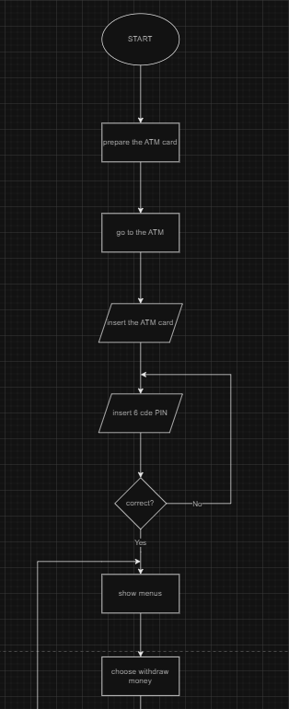Flowchart

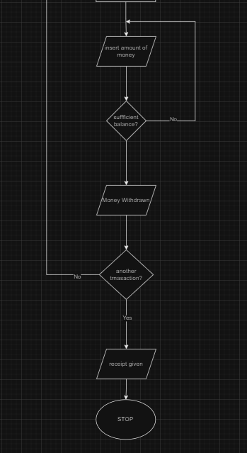

1. Story

It was a sunny afternoon, and Asep realized he needed some cash for the weekend. He grabbed his ATM card from the his wallet and decided to head out to the nearest ATM.

As he approached the machine, He stepped up, inserted the card into the slot, and watched as the screen lit up, asking for his PIN.

Asep entered his 6-digit PIN, his fingers moving with muscle memory. But then, a brief moment of doubt crept in, did he enter the correct number? He glanced at the screen, relieved when the menu appeared, indicating that his PIN was correct.

Navigating the options, he selected the "Withdraw Money" option. The machine prompted him to enter the amount he wanted to withdraw. John hesitated for a second before typing in the desired number.

The screen flashed again, checking his account balance. The machine gives him a message: "Transaction Processing." A moment later, the mechanical hum of the ATM signaled that his money was being dispensed.

As he grabbed the cash, the machine asked if he wanted to make another transaction. Asep pressed "No." A few seconds later, a receipt slid out of the machine, detailing his withdrawal.

With the receipt and cash in hand, Asep smiled and tucked them away in his wallet. The transaction was complete, and the screen displayed a final "Thank You" message.